

Developing the Meaning and Value
of Institutional Research

Sarah Shumpert,
Director of Instructional Support,
Tri-County Technical College
Practicum submitted: February 11, 2010

2. Please include the AIFT Dates and location that you received your training
I attended the AIFT session facilitated by Doug Kerr on November 18 -21, 2009 in Vancouver, BC. I registered for the AIFT with an open mind and heart, but without any idea of when, where or how I might be able to apply the AI process back home. I was looking for both personal and professional renewal by pursuing an area (facilitation) that interested me and for which others saw an innate (if underdeveloped) talent in me. My professional experience is steeped in faculty and instructional development and training, but with limited formal group facilitation methods (other than DACUM facilitation).
3. Brief description of the organization, group, or community you worked with.
After I returned home from the AIFT, I was energized by the training experience and excited to facilitate the AI process, both so I could see it realized in “real life” since I had never participated in an Appreciative Inquiry prior to the training and so that I could earn my certification as a facilitator. One of the reasons I elected to attend AI training was because my institution, Tri-County Technical College, has been working toward becoming a “Learning College” and I knew that other learning colleges had embraced the AI approach. Even though I felt Tri-County wasn’t ready for a whole systems change, and I didn’t know exactly how I would be able to apply AI to my work, I felt it was congruent with the learning college vision our President had set forth and that we could “grow into” AI over time.

After learning that the Institutional Research and Evaluation Office (IREO) at Tri-County was preparing for their annual planning retreat, I approached the director, Dr. Chris Marino, to see if he was interested in “trying something new” and helping me earn certification. Dr. Marino and I have worked on numerous projects together over the last several years and have developed a relationship based on mutual trust and respect. He readily agreed to use the AI process to create a three-year unit plan, even though this was a completely new approach for him.
4. List the names and/or category of stakeholders you included in the Core Group, the cross-section of people that helped you identify the topic and modify the Interview Guide.

As a small system, the entire IREO participated in all AI phases including identifying the topic of inquiry. After the focus of inquiry was identified, I worked with the IREO director to modify the generic Interview Guide.
Name | Title
Dr. Chris Marino | Director
Ms. Margaret Burdette | Coordinator of SACS Assessment and Compliance
Ms. Lisa Saxon | Statistical Analyst
Ms. K.C. Bryson | Administrative Specialist and Survey Coordinator
5. What was the positive topic that the Core Group identified for inquiry? What method did you use to help them identify the topic?

When I initially approached Dr. Marino regarding using an Appreciative Inquiry for the IREO planning retreat, he stated that he had originally intended to use the retreat as a brainstorming session with his staff on ways they could address a problem he described as a lack of integration into the college. He felt that the college community did not utilize the IREO’s existing data reports and did not make use of the IREO’s expertise to conduct new research that could inform decision making. We briefly discussed ways that he might reframe the problem into a positive focus of inquiry, and then agreed to meet at a later time to work on the Definition Phase. I left Dr. Marino with an article to share with his staff as a means of introduction to the AI process.

Although Dr. Marino was initially enthusiastic to try an Appreciative Inquiry, after sharing the article about AI with his staff he began to express concerns over their unfamiliarity with both the terminology and interview methodology used in AI. He suggested that I meet with him and his staff prior to the planning retreat to give an in-person orientation to AI to make everyone feel more comfortable with this new approach, especially with the interview process. I agreed that that was an excellent idea and further suggested that we use the “orientation” meeting to let the entire staff work together to identify the focus of inquiry.

Because I felt that Dr. Marino was becoming increasingly uneasy with the AI approach, I decided to use the two methods I learned during the AIFT to indentify the focus of inquiry: (1) a traditional deficit-based brainstorm of issues, gaps, and problems, and (2) appreciative interviews using the generic interview guide. I remembered how powerful experiencing the contrast of those two methods was for me during the training. It had been one of my own turning points in making the paradigm shift! I felt that giving Dr. Marino such an experience would help alleviate his growing concerns. (See Appendix A)

During our orientation meeting, the IREO staff brainstormed issues, gaps and problems on flip chart paper and then decided that “getting people to use our data” was the top problem they needed to address. We set the brainstormed list aside, hidden from view. The group then paired for generic appreciative interviews, shared their stories, and identified themes on large post-it notes. I invited the group to play around with their themes using affinity grouping on the wall. What emerged from this exercise was the group’s focus of inquiry: “Growing the meaning and value of institutional research.”

We discussed the differences of the two methods at the conclusion of our orientation meeting, and the group commented on how much they valued the appreciative interview process.

6. Attach or include the modified Interview Guide they used, i.e., the Generic Interview Guide slightly modified for the positive topic of the inquiry.

See Appendix B for the modified interview guide.

7. What method of interviews did people use to inquire into exceptionally positive moments, face to face paired interviews, or some other way?

Having completed the Definition phase during the orientation meeting, the IREO planning retreat began at the Discovery phase (See Appendix C). The group met for one day at the home of one of the staff members. After breakfast together, I provided more orientation to the AI approach by providing a brief talk on the Social Constructionist and Image/Action principles of AI. I then invited the group to document a list of Appreciative Agreements on flip chart paper. The group paired up for the appreciative interviews, sitting around tables in Margaret Burdette’s home.

 | 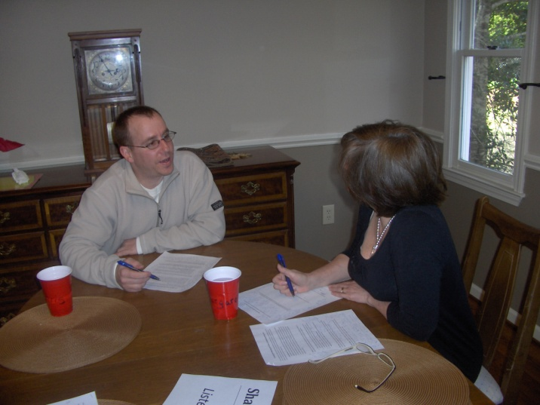
Lisa and KC sit around the kitchen table, while Chris and Margaret sit at the dining room table in the next room.
8. Attach or include a list of the Life-Giving Forces (what they MOST wanted to create MORE of) that the group identified in the stories they shared.
After the interviews, the group sat together and shared their stories. They began to brainstorm themes, identifying the Life-Giving Forces.
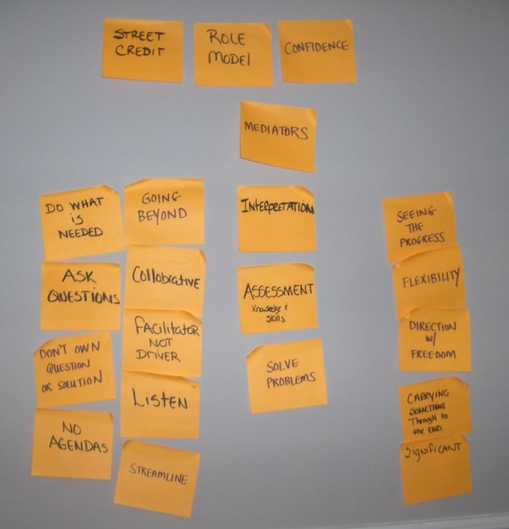
After affinity grouping their themes, the group agreed that they are energized by the supportive family-like atmosphere within the department, where each member enjoys being challenged and gets satisfaction from seeing the impact of the work they do. However, they unanimously (and with visible energy!) decided that the life-giving forces they most wanted more of related to 0how they interact with their clients in the broader institution:
Guide institutional action
“Street credit” Confidence Role model
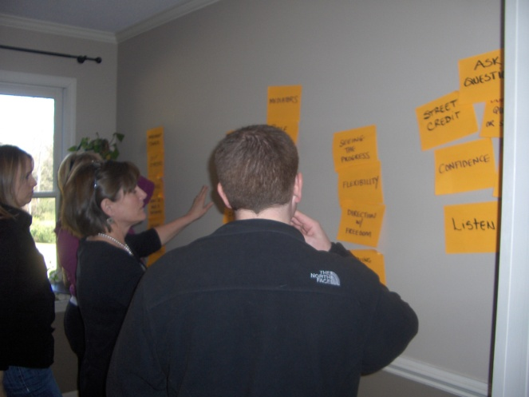 | 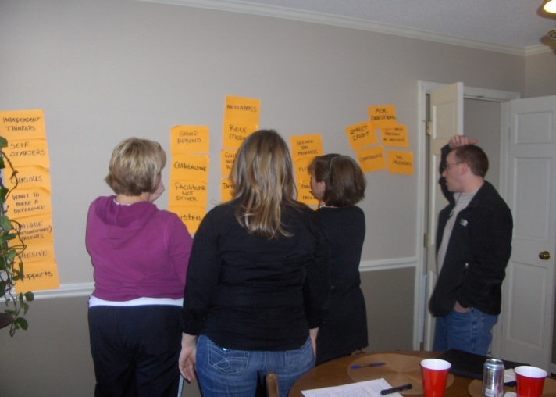

9. Attach or include the Provocative Proposition(s) the group or organization created from the LGFs.

I invited the group to move into the Dream phase by creating a visual image of their preferred future, grounded in the theme of guiding institutional action. This is where a metaphor of a research journey began to emerge.

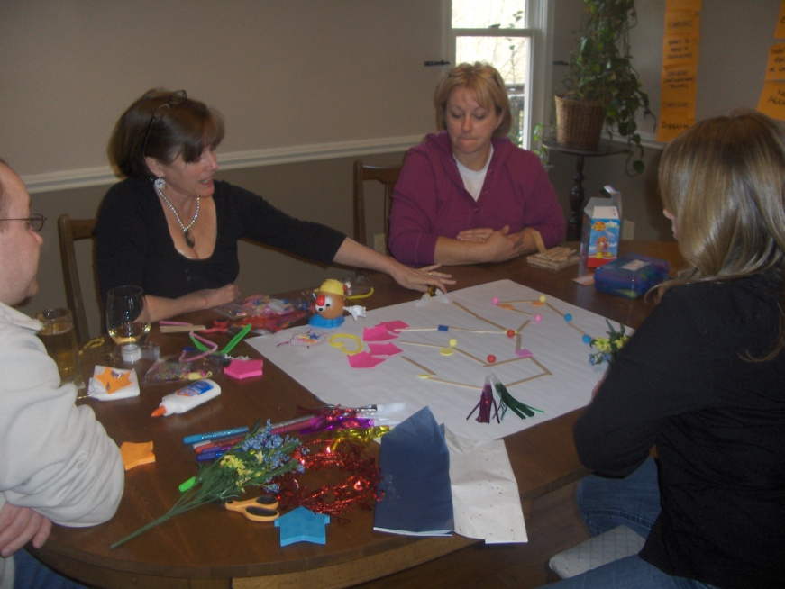
After a break for lunch I invited the group to take a fresh look at the visual image of their preferred future and begin the process of creating a word image. Although the group experienced a post-lunch dip in energy, the excitement rebounded as they imagined themselves co-explorers with their clients, not just generating institutional data but actually guiding clients along a journey from formulating powerful research questions to interpreting data to drawing conclusions that lead to decisions and actions. Their provocative proposition became: With integrity and confidence we provide the light on the path from inquiry to action.
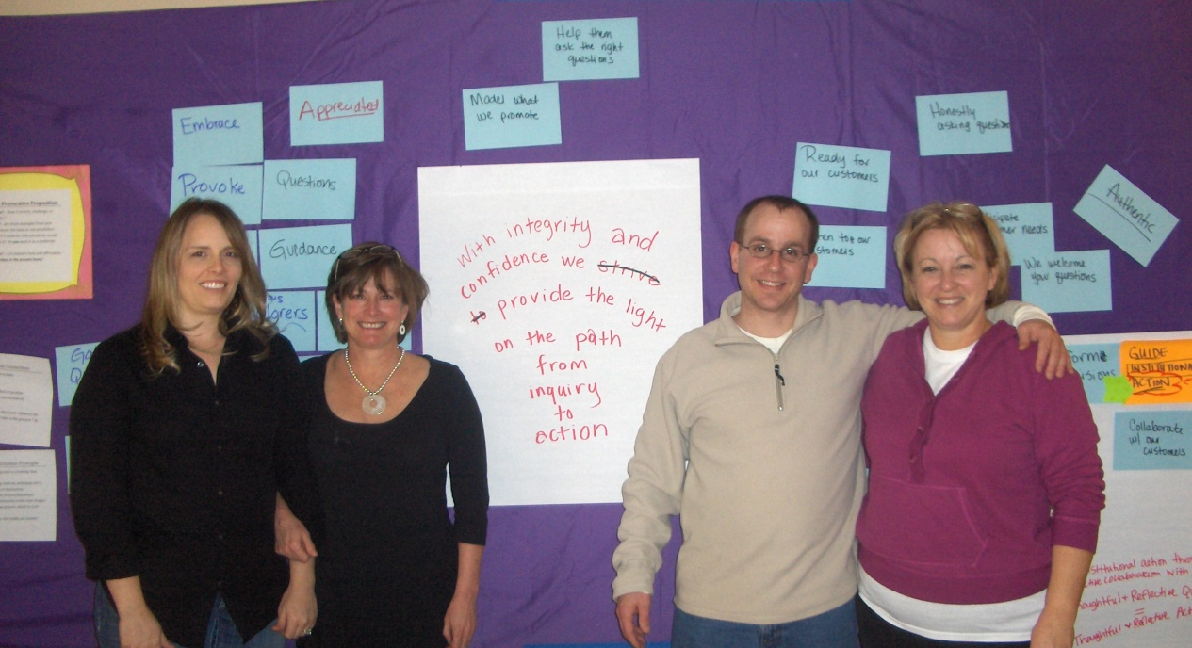
10. Attach or include the Strategic Intentions the group or organization developed to realize the Provocative Proposition(s) they created.

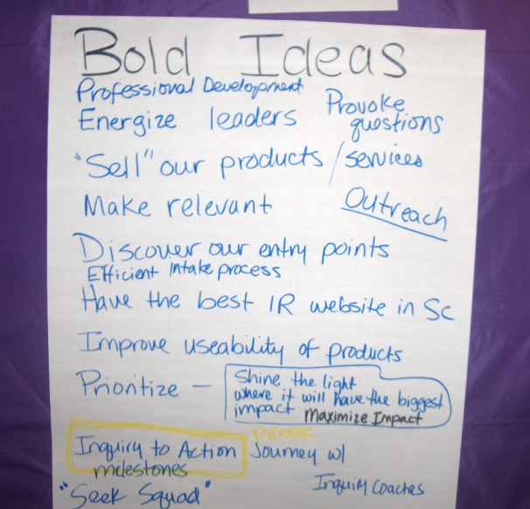
After the group formulated their Provocative Proposition, I invited them to brainstorm a list of bold ideas that would make realizing the provocative proposition inevitable.

The group seemed to struggle at this point with stretching themselves and became somewhat frustrated at my questions of “What else?” and “Is that a bold idea?” Soon the group began a lively debate over what a “bold” action would be and finally decided to focus on creating an Inquiry to Action framework to organize their products and services in a way that will guide clients through milestones along the path of making data-driven decisions. The group will further develop this Inquiry to Action framework by conducting appreciative interviews with their clients that have already successfully used the IREO in this way to inform action.

After the group decided to focus on developing the Inquiry to Action framework, I invited them to make Commitments, Offers, and Requests using the Individual Action Approach. Given the small group size, I felt this was an appropriate approach to get them started on action planning.

11. Impact or Results: What organizational, group or community attitude, process or structure changes have people made as they move toward realizing the Provocative Proposition(s)? What progress have people made toward their Strategic Intentions or Initiatives or Pilot Projects? What stories of success can you share?

The following statement from Dr. Marino describes the immediate strategic results of the Appreciative Inquiry:

The major step that has been taken at the department level so far, is the incorporation of the provocative proposition into the IREO’s mission statement. In addition, the IREO has included a strategic planning initiative to use the results of the inquiry to develop a plan [to create the Inquiry to Action framework] for realizing our provocative proposition.

Also, see Appendix D for comments from some of the participants on how the AI process impacted them individually.

12. What will you do to ensure that people continue to move toward realizing the Provocative Proposition(s)? How will you help them gather stories of success? How will you help them celebrate? How will you, as the AI Facilitator, support their ongoing success?

During the Commitments, Offers, and Requests portion of the planning retreat, I posted an offer to provide on-going appreciative feedback on their Inquiry to Action framework as they develop it. I also made a specific offer to help them compose appreciative interview questions to use with their clients who have successfully moved from inquiry to action utilizing the IREO. As the director of a sister department, I will see the IREO staff on a regular basis in meetings where I plan to serve as a role model by integrating the appreciative inquiry approach to my daily work life.

To help the IREO celebrate their Provocative Proposition, and as a way of saying thanks for helping me complete my AIFT practicum, I gave each staff member a framed photo of the group standing in front of their Provocative Proposition. This photo will serve as a daily reminder of their Provocative Proposition.

13. What did you wish for in the inquiry? What did you learn from the inquiry about yourself and your facilitation? What was your "personal best" experience related to facilitating the Inquiry?

My wish for the inquiry was for the IREO to leave with something concrete that they could include in their unit plan since that was also the director’s wish for his planning retreat. As a team that was already high functioning, I felt certain that the AI process would only serve to deepen the mutual respect they share for each other but I was less certain on how well the process would lead to a concrete action plan.

What I learned most from this inquiry is that I need to trust the process and my own instincts. As a trainer and instructional design consultant, clients look to me for answers. As a facilitator, I need to let go of that feeling of being inadequate or ill-prepared just because I don’t know what the “answer” will turn out to be. Not only is it okay for me not to know the answer, it’s not even my job, as facilitator, to author it.

I felt two of my experiences were a “personal best.” First, I believe that I effectively challenged the group during the initial orientation meeting when they defined their focus of inquiry. Through questioning and rearranging post-it notes on the wall, I believe I helped the group seek “higher ground” because I noticed and drew their attention to two of themes they had written: “meaningful work” and “valuable work.” Defining the focus of inquiry in itself started the IREO down a path they weren’t already traveling. I believe my second personal best was during the portion after the group created their provocative proposition and were brainstorming big ideas to make it inevitable. I allowed a space of discomfort (for them as well as myself) by challenging them with questions like “What else?” and “Is that idea bold?” Even when the group had settled for their initial thoughts, I was confident that they could stretch themselves more and I held the space for them to push through, which they did by debating with each other and igniting their own passion.

14. Have you received permission from the "client" or "clients" to tell us their story? In other words, does Company of Experts.net have permission to share this story with others? If not, who would Company of Experts.net need to contact to receive permission?

Yes, I prearranged with this group to use their experience as my practicum and we included my sharing their story with the Company of Experts in our Appreciative Agreements.
APPENDIX A
Institutional Research
Appreciative Inquiry Orientation/Planning Meeting
January 21, 2010

Overview of Appreciative Inquiry Process
Phase I: Definition (choosing the focus of inquiry)
Method 1(traditional deficit-based approach):
Group brainstorm on problems, issues or gaps (record on flip chart)
Group discussion on top problem, issue or gap (can pick up to 3)
Method 2 (positive appreciative approach):
Paired generic appreciative interviews
Individual completion of summary sheet
Group sharing (round robin) of a highlight and/or quotable quote from your partner’s story (listen only)
Group brainstorm of themes from interview stories (record on flip chart)
Group discussion on top theme (can pick up to 3)
Appreciative assessment of Definition process
Next steps

APPENDIX B
Growing the Meaning and Value of Institutional Research
In pairs, interview one another using the following questions. Be a generous listener. Do not dialogue; rather take turns to actually conduct an interview. If you need more information or clarification, ask additional follow-up questions. Use the summary sheet to record the results of your interview. When your interviews are completed you will present the results to the wider group.
- Best Experience. Tell me a story about one of the best experiences you ever had when a project you worked on was truly meaningful and valuable, an experience where your work had significant positive impact for a group of stakeholders. Who or what initiated the project? How did you come to be involved? What was your role in the project? Who else was involved? What were the circumstances or conditions that made the project have meaning and value? How did your contributions increase the meaning and value? What positive impact did the work have? Who did it impact? How long did the impact last? What do you think made it an exceptionally positive experience?

- Values. Let’s talk a moment about some things you value deeply; specifically, the things you value about yourself; about the nature of your work; and about your organization.

  - Without being humble, what do you value most about yourself –as a person and as a member of the Tri-County college community who contributes meaningful work?
  - When you are feeling best about the significance and impact of your work, what about the task itself do you value?
  - What do you value most about the college community?
  - What is the single most valuable and meaningful thing that the Institutional Research department contributes to the college community?

- Core Value. What do you experience as the core value or factor of your department that allows it to evolve with changing needs and pull through difficult times? If this value/factor did not exist, how would that make your department totally different than it currently is?

- Three Wishes. What three wishes do you have for the Institutional Research department – things that would enable you to engage in even more meaningful work on a daily basis and to truly impact the college community in a positive significant way?

APPENDIX B Cont’d.
Appreciative Interview Summary Sheet
- What was the most appreciative quotable quote that came out of your interview?

- What was the most compelling story that came out of your interview? What details and examples did the interviewee share? How were the interviewee and/or others changed by the story?

- What was the most “life-giving” moment of the interview for you as a listener?

- What theme(s) stood out most for you during the interview?
APPENDIX C
(Agenda with notes for facilitator)
Welcome
Appreciative Agreements
Affirmation of Focus of Inquiry (Definition phase)
Underlying principles of AI (Lecture)
Discovery
- Paired appreciative interviews, using customized protocol
    - Start with specific stories
    - Generalize about life-giving forces
    - Metaphor = think of your topic as a plant. What kind of organizational soil, water, and sunlight conditions that nourish
- Theme identification
  - Share stories
  - Brainstorm themes (life-giving forces)
    - Pick 3-5 “What do you MOST want to create MORE of?”
  - Map the positive core (scattergram)
    - Seek divergence (rather than convergence)
    - Seek synergy (rather than consensus)
    - Seek higher ground (rather than common ground)
CHOOSE ONE THEME w/sub-themes if desired =POSITIVE CORE
Dream
- Visual image (metaphor)
- Provocative Proposition
Design
- Bold ideas
- Individual Action Approach
  - Commitments – actions that can be easily taken, typically within one or two weeks within existing structures
  - Offers – a form of a “gift” to work on something specific
  - Requests – what one person on the team needs from others on the team
Deliver/Destiny
- Recognize and celebrate what is being learned and transformed
- Initiate inspired actions
- Systematically apply AI to programs , processes, and systems
APPENDIX D
Testimonials
Chris Marino
Recently, the Institutional Research and Evaluation Office (IREO) at Tri-County Technical College participated in an Appreciate Inquiry, facilitated by Sarah Shumpert, to help support departmental planning. The IREO provides several services that can be classified as ad-hoc research, evaluation and assessment, or institutional auditing. The principle value of these services is to support decision makers by investigating and answering questions. One of the goals for the appreciative inquiry session was to help the IREO identify, as a team, the core strengths of the office in supporting decision makers. After much discussion, we finally developed our provocative proposition, which was:
“With integrity and confidence, we provide the light on the path from inquiry to action.”
Personally, I found the process of developing our proposition informative, useful and affirming. The positive nature of the discussion emphasized the strong inter-personal relationships in the office, as well as the clear desire from all involved to help others. I was excited and energized by the way the team worked together to identify our department’s strengths. The mood in the discussion was markedly more positive than a previous session in which we concentrated on what the office was not doing well. I felt that Sarah did an excellent job of fostering our discussion without interjecting her views into the dialogue. I also feel that Sarah helped us to synthesize the core elements of our dialogue into a specific, concrete theme.
The major step that has been taken at the department level so far, is the incorporation of the provocative proposition into the IREO’s mission statement. In addition, the IREO has included a strategic planning initiative to use the results of the inquiry to develop a plan for realizing our provocative proposition.
~~~~~~~~~~~~~~~~~~~~~~~~~~~~~~~~~~~~~~~~~~~~~~~~~~~~~~~~~~~~~~~~~~~~~~~~~~~~~~~~~~~~~
Lisa Saxon
I felt that the AI process was a great success. The first day we met as a group at the College, I was afraid that we were focusing too much on improvements that were needed, but we quickly turned that around and started focusing on what we were doing well and how those processes could be improved upon. I like the fact that we all had input and sharing that input caused me to look at our processes differently. I guess getting another person or person’s perspective on things can cause you to look at things in ways that maybe you had not thought of before.
As far as how it has affected me personally, I feel that going through the process caused me to think differently and therefore I have been able to apply that way of thinking not only to my work environment but also to my home environment. I really do feel that at home, I tended to focus too much on how to make things flow smoother or work better when I should have been focusing on what was already working well and go with that. I have made a dramatic change in how I am dealing with my college age son as far as approaching the homework, grades, studying situation. I realize that I focused too much on the fact that he was not preparing himself as I would have in that situation and saw that he has he own way of preparing, and my constant nagging made him disconnect and not want to do anything. So, I guess mine has been more of an attitude change.
~~~~~~~~~~~~~~~~~~~~~~~~~~~~~~~~~~~~~~~~~~~~~~~~~~~~~~~~~~~~~~~~~~~~~~~~~~~~~~~~~~~~~`KC Bryson
First, I want to thank you for the wonderful job you did with facilitating our planning retreat. You were organized, well-spoken and friendly. And your relaxed yet knowledgeable approach made for a productive and enjoyable meeting. I look forward to putting our inquiry into action as I continue with my on-going work and as I take on new projects to help our department achieve its mission. I feel inspired by our provocative proposition, and I am proud of my part in helping develop it. I have also incorporated this positive approach at home, and have already seen differences in attitudes and behaviors there!

